A000-Eur-Portugal-Paleo-Hafted Hammerstone-c 15,000 BCE

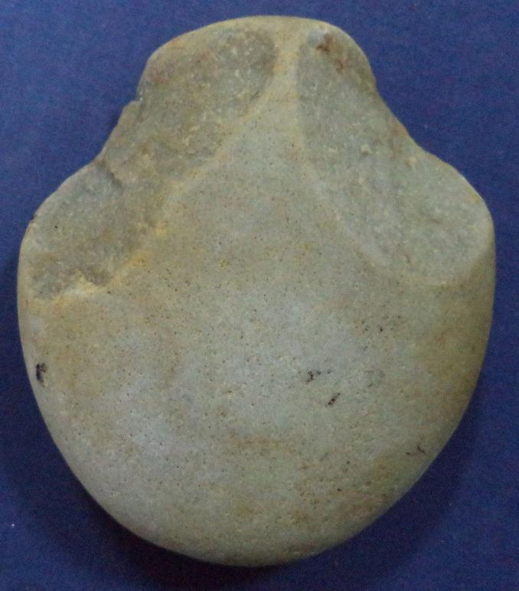 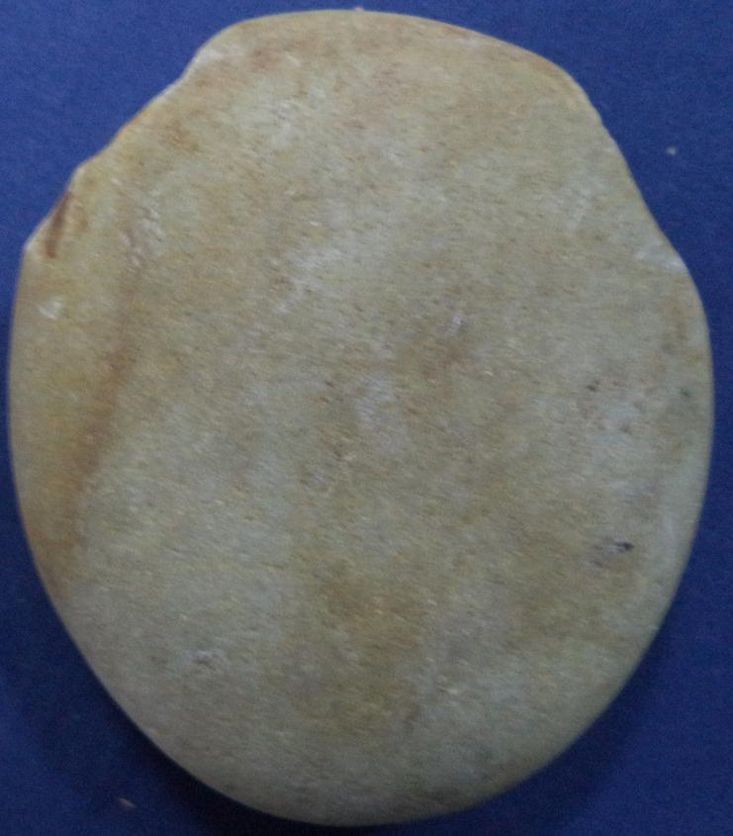

Case no.: 1

Accession Number:

Formal Label: Portugal-Paleo-Hafted Hammerstone-c 15,000 BCE

**Display Description:**

**LC Classification:**

Date or Time Horizon:

Geographical Area:

**Map:**

**GPS coordinates:**

Cultural Affiliation:

Media:

Dimensions: H 9.7 cm; L 8.4 cm

Weight: 324 grams weight

Condition:

Provenance:

**Discussion:**

**References:**

Paleolithic hand axe from Iberian tribes.  
  
324 grams weight  
9,7 cms high  
8,4 cms long

